SAMPLE: FY22 NEW CONSTRUCTION WITH INCREMENTAL UPGRADES
PROJECT DESCRIPTION/SCOPE OF WORK

To assist with developing your FY22 application proposal, below is an example of a project description/scope of work for a multi-family new construction with incremental upgrades. Please note that this is only an example and the scope of work adopted as part of a grant agreement may differ.

DELIVERABLES
The deliverables described below shall be designed, purchased, developed, and implemented by [Insert Grantee Name] hereinafter “Grantee.” Each of these deliverables shall include cost effective measures that directly contribute to energy savings and/or facilitate energy conservation behavioral practices in Maryland.

1. Energy Efficiency Upgrades

- Grantee has identified [Insert Building/Home Name], a proposed new construction building in [Insert County] as the eligible candidate facility serving low-to-moderate income Marylanders to receive an energy efficiency upgrade under this Grant. The facility consist of will consists of [XX] one and two-bedroom units.
- Grantee shall provide personnel to comply with the reporting and invoicing requirements of this Grant.
- All work shall be completed by contractors and/or staff holding all necessary certifications and licenses. Additionally, all work performed pursuant to the Grant shall comply with all applicable local, State, and federal building codes.

2. Design Upgrades Scope of Work at [Insert Building/Home Name]

- Grantee shall provide the upgrades consistent with this Grant at [Insert Building/Home Name]
- Project Location:

[Insert Project Location (address)]

  - Grantee shall provide incremental cost upgrades. These incremental cost upgrades are the proposed design upgrades over the minimum IECC 2015 Baseline performance requirements. Energy savings will result from the energy efficiency design upgrades over the minimum required baseline codes. Grantee shall upgrade [Insert Building/Home Name] facility by carrying out the following:

- Energy Star V3.1 packaged split system heat pumps in unit & common areas.
- Energy V3.1 Ductless split system.
- Ultra-high efficiency central gas fired hot water.
- All LED high efficiency interior lighting package for 21% reduction below IECC code
- All LED high efficiency exterior lighting for 74% reduction below IECC code.
- Energy Star Appliances: Fridge, dishwasher & range exhaust fan
- Interior & attic air sealing package.
- High performance, liquid applied water resistive barrier (WRB) air barrier.
- Improved insulation walls.
- Improved insulation roof.
- Energy star window & sliding door package.

Additional details regarding the proposed upgrades over the code baseline are shown below:

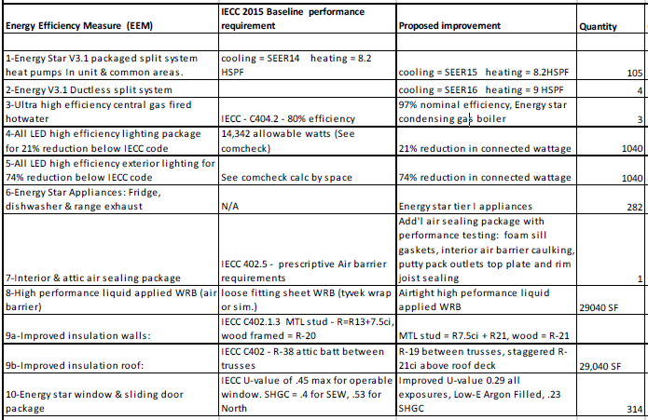

Note: This scope example is based on a past project that was selected by the LMI review team when the IECC Code for Maryland was 2015. The current IECC code for Maryland is 2018.

